# CHAPTER 1

**INTRODUCTION**

Visually impaired individuals face a significant challenge in accessing reading resources independently, especially when visiting places such as stores, restaurants, and hospitals, where they often rely on the assistance of others. Various technologies have been developed over time to solve this problem, initially focused on generating text equivalents in Braille. However, these early implementations had practical limitations, such as being time-consuming, bulky, and expensive. As a result, alternative technologies have emerged that aim to provide various forms of feedback for printed text.

Efforts have been made to create audio versions of books based on the Braille system. However, using cassettes or tapes presented problems in terms of proper placement and the ability to navigate to specific areas of text. To improve the reading experience, the Digital Accessible Information System (Daisy) standard was introduced, which combined text and audio components in accessible books, offering a more interactive reading experience.

The first assistive devices for the blind explored the conversion of visual signals into non-verbal acoustic or tactile output. For example, the Optophone used musical chords or motifs, while the Optacon relied on vibrotactile signals. However, these devices had limitations, such as the need to move the hands or not being able to freely use both hands when reading.

The advent of optical character recognition (OCR) technology has brought a new wave of innovation. OCR enables the extraction of text from images, which enables mobile apps for reading aids such as KNFB Reader and Blindsights Text Detective. These applications use OCR and speech synthesis to capture and read text from images. However, they require proper alignment, lighting and focus to achieve optimal results. Additionally, they often read blocks of text as a whole without providing relevant information to the user.

Specialized devices such as Eye-Pal and OrCam have been developed to assist in reading and analyzing texts. For example, OrCam uses a head-mounted camera system to recognize objects and read printed text in real time, activated by a pointing gesture. Similarly, devices such as iCare and Finger Reader use cameras to capture images of text and provide auditory or tactile feedback. However, these devices tend to be bulky, lack real-time effects, and require external components or complex hardware setups.

The existing literature highlights the need for a computationally inexpensive algorithm to address the challenges faced by visually impaired individuals in accessing reading resources. Current systems often rely on software technologies with complex hardware setups, leading to cost and portability issues. In response to these challenges, this paper aims to present a simple algorithm that offers satisfactory results using cost-effective methodologies.

Overall, the development of assistive technologies for visually impaired individuals has evolved from generating Braille equivalents to exploring alternative feedback systems such as audio, acoustic or tactile outputs. The introduction of OCR and advances in computing further expanded the possibilities. However, there remains a need for more accessible and affordable solutions that can effectively address the challenges visually impaired individuals face in accessing reading resources independently.

* 1. **MOTIVATION**

One of the main challenges faced by visually impaired individuals is the difficulty of accessing reading resources. This limitation is particularly noticeable when they visit places such as shops, restaurants or hospitals and have to rely on the help of others. Early implementations of assistive technologies focused primarily on generating text equivalents in Braille, but faced practical challenges such as time constraints, bulk, and high cost. Alternative technologies that provide various forms of feedback for printed text have been explored, including acoustic versions of books and the introduction of the Digital Accessible Information System (Daisy) standard.

Advances in computing led to optical character recognition (OCR) technology that allowed text to be extracted from images. Mobile reading assistance apps such as KNFB Reader and Blindsights Text Detective used smartphones and OCR to capture and read text aloud. However, these applications had their limitations and required clear text placed at certain distances for optimal results. Specialized devices such as Eye-Pal and OrCam were also developed to assist in reading and analyzing texts, but still had disadvantages such as bulkiness and lack of real-time functionality.

To address these issues, researchers have developed wearable text recognition solutions. The Finger Reader, a finger-mounted device, captured images of text and provided tactile feedback via vibration motors using software with algorithms for text extraction, OCR, and text-to-speech synthesis. Handsight used a miniature camera attached to a wristband and proprietary software running on a PC or iPad. However, limitations included the need for physical prototypes, problems with software interface knowledge, and differences in readability between digital devices and physical paper.

Considering the existing literature, there is a clear need for a computationally efficient algorithm to solve the problems faced by visually impaired individuals. Current systems often rely on complex hardware and software, making them less accessible and cost-effective. The motivation of this paper is to present a simple algorithm that offers satisfactory results with cost-effective methodologies and bridges the gap in existing solutions for visually impaired readers. By developing an algorithm that can efficiently process and interpret text, the goal is to provide visually impaired individuals with a more accessible and affordable solution for reading printed materials.

The impact of this research lies in its potential to significantly improve the reading experience for visually impaired individuals. By offering a simple algorithm that can be implemented using cost-effective methodologies, this solution has the potential to overcome the limitations of existing systems. It can give visually impaired readers more independence as they no longer have to rely solely on the help of others to read printed text. Additionally, the algorithm can be integrated into various devices, including smartphones or wearables, further increasing accessibility and ease of use.

1. Increased Access to Information: One of the major challenges faced by blind or visually impaired individuals is the difficulty in accessing printed materials such as books and documents. The development of technologies like Braille, screen readers, and finger readers has made it possible for them to read, understand, and navigate through written content. These tools have opened up a vast world of information, enabling blind individuals to pursue education, engage in professional work, and stay informed about current events.
2. Enhanced Education and Employment Opportunities: Access to information plays a crucial role in education and career advancement. By providing blind individuals with tools that allow them to read and comprehend written materials, these technologies empower them to pursue academic degrees, acquire vocational skills, and compete in the job market. This increased access to education and employment opportunities helps to promote inclusivity and reduce societal barriers.
3. Independence and Autonomy: The ability to access and understand information independently is essential for blind individuals to lead more autonomous lives. Technologies like screen readers, finger readers, and Braille notetakers enable them to read, write, and navigate digital content, reducing their reliance on sighted assistance. This independence fosters self-confidence and empowers individuals to actively participate in various aspects of life.
4. Social Inclusion and Participation: Access to information is vital for social inclusion and participation. Blind individuals often face challenges in social interactions, as they may not have access to visual cues or written information. With technologies like screen readers and Braille displays, blind individuals can participate in online conversations, access digital content, and stay connected through social media platforms. These technologies bridge the information gap and enable blind individuals to engage more fully in social and cultural activities.
5. Continuous Technological Advancements: The motivation behind the development of these technologies is to continually improve the accessibility and usability of information for blind or visually impaired individuals. Researchers and developers strive to enhance existing systems, create more cost-effective solutions, and introduce new innovations that address the specific needs and challenges faced by this population. The goal is to make technology more user-friendly, portable, and efficient, ultimately improving the overall quality of life for blind individuals.
   1. **PROBLEM STATEMENT**

"OCR-Guided Wearable Solution for Visual Impairment Support"

* 1. **OBJECTIVES**

The objectives of the proposed work is to :

1. Develop a robust system utilizing LDR sensors to accurately detect and analyze ambient light conditions in real-time, enabling optimal adjustments for visually impaired individuals during reading activities.
2. Implement image processing techniques to detect and determine the orientation of printed text, providing prompt notifications to the user regarding the text's alignment and ensuring a seamless reading experience.
3. Integrate the powerful tessaract OCR engine into the system, enabling efficient extraction of text from captured images, with a focus on optimizing accuracy and speed. Subsequently, employ advanced Python text-to-speech conversion methods to transform the extracted text into natural and intelligible speech output, enhancing accessibility for visually impaired users.
   1. **SCOPE OF THE PROJECT**

Overall, the project aims to develop a standalone Raspberry Pi-based system that enables visually impaired individuals to read printed text by pointing their finger. The system will involve the integration of various hardware components and software algorithms to capture, enhance, recognize, and convert the text into acoustic output, providing an accessible reading experience for visually impaired users.

1. Development of a Wearable Assistive Device: Design and implementation of a wearable device that can be easily worn by visually impaired individuals, incorporating a finger-mounted camera, LDR sensor, and audio output device.
2. Ambient Light Detection: Integration of an LDR sensor to detect ambient light conditions and adjust the device's illumination accordingly, ensuring optimal lighting conditions for reading.
3. Image Capture and Enhancement: Utilization of a webcam to capture images of printed text, followed by image enhancement techniques to improve the quality and clarity of the captured images for accurate text recognition.
4. Optical Character Recognition (OCR): Integration of an OCR engine, such as tessaract OCR, to accurately recognize and convert the extracted text into a digital format.
5. Text-to-Speech Conversion: Utilization of Python-based Text-to-Speech (TTS) conversion techniques to convert the recognized text into audible speech output, allowing visually impaired users to comprehend the content.
6. Audio Output Device: Provision of an audio output device, such as earphones or a speaker, to deliver the synthesized speech output to the user.

# CHAPTER 2

**LITERATURE SURVEY**

**2.1 IMAGE PROCESSING :**

Image processing involves using techniques and algorithms to manipulate digital images in order to improve their quality, extract useful information, or perform specific tasks. It is a field within the broader domain of signal processing, where the input signal is an image or a sequence of images (e.g., video frames) and the output can be an enhanced image, a set of features, or some other derived information related to the image.

Image processing encompasses a wide range of operations, including but not limited to:

* + - 1. Image enhancement: Techniques to improve the visual quality of an image, such as adjusting brightness, contrast, or sharpness.
      2. Image restoration: Methods to remove noise, distortions, or artifacts from images to restore their original or desired appearance.
      3. Image segmentation: The process of partitioning an image into meaningful regions or segments based on certain characteristics or properties, often used for object detection or image understanding.
      4. Feature extraction: Identifying and extracting specific features or patterns from an image, which can be used for various purposes like object recognition, image classification, or image matching.
      5. Image compression: Techniques to reduce the size of an image file while preserving its essential information, allowing for efficient storage and transmission.
      6. Image recognition: Using machine learning or computer vision algorithms to automatically identify and classify objects or scenes within an image.

These are just a few examples of the many applications and techniques involved in image processing. It is a fundamental technology used in various fields such as medical imaging, surveillance systems, remote sensing, robotics, and more.

**2.2 AI Enabled IoT :**

The combination of Artificial Intelligence (AI) and Internet of Things (IoT) has opened up new possibilities and capabilities in various industries. AI-enabled IoT systems leverage the power of AI algorithms and techniques to extract valuable insights from the vast amounts of data collected by IoT devices. This integration allows businesses to make informed decisions, automate processes, and drive smart actions based on real-time analysis.

1. Data Collection: IoT devices, equipped with sensors, gather data from the physical world. These sensors can be embedded in various objects, machines, or environments, collecting information such as temperature, humidity, pressure, location, motion, and more.
2. Data Communication: The collected data is transmitted through internet connectivity to a central system or cloud platform. This enables seamless and real-time communication between IoT devices and the AI algorithms that process the data.
3. Data Aggregation: The collected data is aggregated and stored in a centralized location or cloud infrastructure. This consolidation allows for efficient data management and accessibility.
4. Data Analysis: AI algorithms and techniques are applied to analyze the collected data. Machine learning, deep learning, and other AI methods can extract patterns, trends, correlations, and anomalies from the data, providing valuable insights and predictive capabilities.
5. Informed Decision Making: The analyzed data and insights derived from AI algorithms enable businesses to make informed decisions. These decisions can be related to optimizing operations, improving efficiency, predicting maintenance needs, identifying patterns, personalizing user experiences, and more.
6. Automated Actions: Based on the insights gained from data analysis, AI-enabled IoT systems can take automated actions or trigger responses. For example, adjusting environmental conditions in a smart home based on occupancy patterns, optimizing energy usage in industrial settings, or automatically detecting and responding to anomalies in a manufacturing process.

**2.3 Text to speech :**

Pyttsx3 is a Python library that provides text-to-speech (TTS) capabilities for applications. In the context of a wearable assistive device for the blind, Pyttsx3 could be used to convert digital text, such as OCR output from Pytesseract, into spoken words that the user could hear through headphones or speakers. Features of Pytesseract are as follows,

1. Cross-platform compatibility: Pytesseract can be used on various operating systems, including Windows, macOS, and Linux.
2. Language support: Pytesseract supports over 100 languages for OCR, including English, Spanish, French, German, Chinese, and Japanese.
3. Customization: Pytesseract allows users to customize various OCR parameters, such as page segmentation mode, OCR engine mode, and character whitelist.
4. Integration with other Python libraries: Pytesseract can be easily integrated with other Python libraries for image processing, such as OpenCV and Pillow.
5. Easy to use: Pytesseract is simple to install and use, making it a popular choice for developers who need to add OCR functionality to their applications.

Pytesseract could be used in a wearable assistive device for the blind:

1. Capture image: The device would need to capture an image of the text using a camera or other image-capturing device.
2. Pre-process image: Before passing the image to Pytesseract, it may be necessary to pre-process the image to improve the accuracy of the OCR. This could involve operations such as image binarization, deskewing, or noise reduction.
3. Apply OCR using Pytesseract: The pre-processed image would then be passed to Pytesseract to perform the OCR. Pytesseract would analyze the image to identify the characters and their positions within the image.
4. Extract text: Once the OCR has been performed, the text would be extracted from the image as a string of characters. The extracted text could then be read out loud using a text-to-speech module or displayed on a braille display for the user to read.
5. Repeat for multiple images: The device could continue to capture and analyze images until the user no longer needs the OCR functionality.

**Table 2.1** Literature Survey

|  |  |  |  |  |
| --- | --- | --- | --- | --- |
| **Author and year** | **Title of the paper** | **Methodology** | **Findings** | **Short comings** |
| Arunima B Krishna Mcghana Hari  Dr.Sudheer.A.P  2019 | Word Based Text Extraction Algorithm Implementation in Wearable Assistive device for blind. | Capturing the image, processing to extract the intended word and final audio output to the earphone or the audio jack. | Provides assistance to blind or visually impaired person to read a book. | The device assists the blind through a voice where voice is an intended word pointed by the user and it takes approximately 5s. |
| Trupti Shah Sangeeta 2019 | Efficient Protable Camera Based Text to Speech Converter for Blind Person. | Detecting the object region, Localiztion of text on object, extraction of text and text to speech conversion. | The experiment and training are performed on Synth 90k word dataset and using OCR and CRNN a model has been developed. | Combination of OCR and CRNN overcomes drawback of individual and gives better result which successfully recognizes text image and convert it into speech for blind person. |
| Shalini Sonth Jagadish S 2017 | OCR Based Facilitator for the Visually Challenged. | Acquisition of image and preprocessing, extracting a text from the image and text-to-speech conversion. | The image is captured after 10 seconds of button is being pressed and sent to processing. | Applying Otsu’s threshold and Gaussian blur for denoising the image. |
| Sneha.C. S.B.Gundre 2019. | OCR Based Image Text To Speech Conversion Using MATLAB. | Optical Character Recognision, Biniarization, Segmentation,Feature Extraction, Recognition. | Text is extracted from the input image using OCR then the extracted text is converted into speech using TTS in Matlab | The advantage of this system does not need the internet connectivity that is a basic necessity for other TTS system like a Google TTS in Google Keep. |
| Thomas Portele, Jiirgen Kramer-2018 | Adapting a TTS system to a reading machine for the blind. | Systhesis systems that convert orthographic text into speech usually make assumptions about the input that are no longer valid when used in combination with a scanner and OCR sofiwaxe. | The combinatin on of a scanner and OCR software might sometimes lead to obscun input for the synthesis system; this is especially the case when scanning faxes. In our experience nearly everythingis possible | Speech synthesis systems are developed with the main focus on speech quality.But ease of use and robustness are as important for many users as high-quality speech. |
| Akash Singh, Vaishali Kushwaha, Shilpa Mishra -2018 | An Efficient Auxiliary Reading Device for Visually Impaired | Optical Character Recognition (OCR) and finally narration of converted text using Text to Speech synthesizer (TTS) | The device performs its operation through the serial integration of 4 operations in-line with next to each scanning, image pre-processsing, extraction of text using microcontroller using series of algorithms and various engines like OCR | Bottom up design methodology was used in the development of device. The frame and casing of the google were designed using lightweight materials. |
| Prabhakar Manage, Veeresh Ambe Prayag Gokhale -2019 | An Intelligent Text Reader Based on Python | The input image is enhanced using Image Procssing techinques. The Tesseract OCR engine embedded in the Raspberry Pi searches for the text in an improved image and converts it into digital document | The main objective of the designed product is to assist the visually impaired people and serve them economically and efficiently | Python based portable virtual text reader is discussed. This reader is used to read out the text aloud for various applications |

# CHAPTER 3

**SYSTEM ANALYSIS**

* 1. **EXISTING SYSTEM :**

The advancements in technology have paved the way for various systems aimed at assisting visually impaired individuals. One such system is Braille, a tactile writing system that uses raised dots to represent symbols from different languages. Screen readers have also emerged as a valuable tool, reading aloud text displayed on screens through braille displays or text-to-speech synthesizers. Wearable devices like the Finger Reader enable users to scan and receive audio feedback of printed text, while Braille Notetakers offer alternative input methods for computers. Braille Printers emboss hardcopies of braille, and Screen Magnifiers enlarge screen content for improved visibility. E-Book Readers provide portable access to e-books with text-to-speech functionality. Ongoing research focuses on tactile touch screen systems, and a newly developed system incorporates their principles with added features for enhanced usability. These advancements continue to make a meaningful impact on the lives of visually impaired individuals by providing accessible and user-friendly solutions.

1. Braille: Braille is a system that uses 6 raised dots in a 2x3 fashion per cell to represent symbols. It is a tactile writing system designed for visually impaired individuals. Each dot pattern represents a letter, punctuation, or symbol from a known native language. Braille can be used for various languages and is available in different grades, including Grade-1, Grade-2, and Grade-3.
2. Screen Reader: A screen reader is a technology that reads aloud the text displayed on a screen or monitor of a computer, mobile device, or tablet. It uses either a refreshable braille display or a text-to-speech synthesizer to make the text accessible to visually impaired users. The screen reader interacts with the operating system to gather information from the screen and provide auditory feedback.
3. Finger Reader: The Finger Reader is a wearable device worn on the finger that helps visually impaired individuals access plain printed text. Users can scan a text line with their finger, and the device provides audio feedback of the words as well as haptic feedback of the layout. It assists with maintaining straight scanning and alerts the user if they deviate from the baseline.
4. Braille Notetaker: A Braille Notetaker is a device that replaces standard QWERTY keyboards to provide input to a computer for visually impaired individuals. It often incorporates a text-to-speech synthesizer and may include a refreshable braille display for output. This device helps visually impaired individuals in their daily tasks by providing a more accessible input method.
5. Braille Printer: A Braille Printer, also known as an embosser, is a hardware device that prints hardcopies of braille. It utilizes braille translation software to convert electronic text from a computer into braille. The printer typically uses heavyweight paper to print braille on both sides. Although slower, noisier, and more expensive than regular printers, it enables visually impaired individuals to obtain physical copies of braille documents.
6. Screen Magnifier: A Screen Magnifier is a computer graphical output that enlarges the displayed content on the screen. It is primarily used to improve visibility and computing power for individuals with visual impairments. By magnifying the content, it helps visually impaired users see and interact with information more effectively.
7. E-Book Reader or Audiobook Reader: An E-Book Reader or Audiobook Reader is a device that reads electronic books (e-books) displayed on a screen. It typically includes features such as push-button or touch screen gestures for navigation. The device utilizes text-to-speech functionality to read aloud the e-book content. It is popular due to its portability and availability for visually impaired individuals.
8. Tactile Touch Screen System (Research): This paragraph mentions a research work in progress. It describes a system where visually impaired individuals can move their fingers on an electronic text document displayed on a touch screen device. The touched word is then read aloud to the user. The system incorporates a framework of tactile landmarks to assist with navigation on the display.
9. Developed System: The last paragraph mentions the development of a system based on the principles described in the previous research work. The system highlights the functionalities of the tactile touch screen system and includes additional features to enhance its efficiency, operability, and flexibility for visually impaired individuals. It aims to provide a user-friendly solution for the visually impaired community.
   1. **DISADVANTAGES :**

While the mentioned technologies offer valuable support for visually impaired individuals, it's important to consider some of their limitations and potential disadvantages:

1. Braille:
   1. Limited availability: Braille materials may not be readily accessible in all contexts, limiting the availability of braille content.
   2. Steep learning curve: Learning braille requires time and effort, making it a barrier for individuals who may struggle with mastering the system.
   3. Limited representation: Braille primarily represents written text and may not fully capture graphical information, such as charts or diagrams.
2. Screen Reader:
   1. Inaccurate text interpretation: Screen readers may encounter challenges in accurately interpreting complex formatting or non-standard text layouts, resulting in incorrect or confusing auditory output.
   2. Limited support for visual context: Screen readers may struggle to convey visual elements, such as images or spatial relationships, which can impact the overall comprehension of content.
3. Finger Reader:
   1. Dependency on physical contact: The Finger Reader relies on physical contact with the printed text, which may not be suitable for sensitive or fragile documents.
   2. Limited accuracy: The device's scanning accuracy may be affected by variations in finger movement, leading to potential errors in the audio feedback.
4. Braille Notetaker:
   1. Limited compatibility: Braille Notetakers may face compatibility issues with certain software programs or platforms, restricting their functionality in specific environments.
   2. Higher cost: Braille Notetakers tend to be more expensive compared to conventional QWERTY keyboards, making them less accessible for some users.
5. Braille Printer:
   1. Cost and accessibility: Braille Printers are often more expensive than standard printers, making them less accessible for personal use. Additionally, the availability of braille paper and the bulkiness of embossed braille copies can pose logistical challenges.
6. Screen Magnifier:
   1. Loss of context: Enlarging the screen content can lead to a loss of context, as users may only see a portion of the information at a time.
   2. Distortion and visual fatigue: The magnification process can introduce distortion or blurriness, and prolonged use of screen magnifiers may cause eye strain and fatigue.
7. E-Book Reader or Audiobook Reader:
   1. Limited format compatibility: E-Book Readers may not support all e-book formats, which can restrict the range of available materials for visually impaired individuals.
   2. Potential limitations in navigation: Some e-book formats may not provide sufficient navigation features, making it challenging for users to quickly locate specific content within the book.
   3. **DISADVANTAGES :**

The wearable assistive device for the blind discussed here aims to provide a solution for reading text and converting it into speech format, thereby enabling visually impaired individuals to access written information more easily. This device leverages various technologies and components to accomplish this task, ensuring accessibility and usability for its users.

The core component of the device is a Raspberry Pi microcontroller, which serves as the primary computing platform. The Raspberry Pi is a versatile and compact device capable of running various software applications, making it an ideal choice for this wearable assistive device.

To facilitate text reading, the device incorporates a camera as one of its key sensors. The camera captures images of text, which are then processed and converted into readable content by the Raspberry Pi. This process involves optical character recognition (OCR) techniques, where the captured text images are analyzed and transformed into machine-readable text.

The Raspberry Pi utilizes machine learning algorithms to process the text images and extract the corresponding characters. This involves training the algorithms on a large dataset of text samples to enable accurate recognition of characters, regardless of font style or size. The machine learning algorithms continuously improve their accuracy and performance over time as more data is processed, ensuring better text recognition results.

Once the characters are recognized, the Raspberry Pi converts them into a format suitable for speech synthesis. The device incorporates a text-to-speech (TTS) engine, which generates speech output based on the recognized text. The TTS engine converts the text into spoken words, allowing the visually impaired user to listen to the content in real-time.

To ensure accurate text recognition and reliable speech synthesis, the device incorporates additional features and components. These include appropriate lighting conditions for capturing clear text images, autofocus capabilities for maintaining sharpness, and image stabilization to minimize blurriness caused by hand movements.

The device also includes audio output functionality to deliver the synthesized speech to the user. This audio output can be integrated with bone conduction technology, where sound vibrations are transmitted directly to the inner ear through the bones of the skull. This approach allows the user to perceive the synthesized speech without obstructing their ears, enabling them to remain aware of their surroundings.

Moreover, the device incorporates a user interface that enables interaction and control. It may include physical buttons or touch-sensitive surfaces that allow users to navigate through menus, adjust settings, and activate specific functionalities. The user interface is designed to be accessible and intuitive, considering the needs and limitations of visually impaired individuals. Large, tactile buttons and audio cues can be incorporated to provide a tactile and auditory feedback loop to the user.

To enhance the user experience, the device can also integrate connectivity features. It can connect to the internet to access online resources, such as databases, libraries, or web services, to retrieve additional information or provide more context for the recognized text. This connectivity also allows for software updates, ensuring that the device remains up-to-date with the latest improvements and advancements in text recognition and speech synthesis technologies.

The wearable nature of the device is also an essential aspect of its design. It is designed to be lightweight, comfortable, and unobtrusive, allowing users to wear it for extended periods without discomfort. The device can be worn on the wrist, attached to a belt, or integrated into clothing, ensuring flexibility and personalization for the user's preferences.

Power management is another important consideration. The device is powered by a rechargeable battery, which provides mobility and convenience. The battery life is optimized to ensure sufficient usage time between charges, taking into account the power requirements of the various components and sensors. The device can be easily recharged using standard USB charging cables, eliminating the need for specialized or proprietary charging solutions.

Accessibility and customization features are incorporated into the device design. The user interface can be adapted to accommodate different user preferences, such as adjusting the volume and speed of the synthesized speech. Users can also customize

**3.4 ADVANTAGES OF THE SYSTEM**

The text-to-speech functionality of the wearable assistive device for the blind offers several advantages that significantly improve the user experience and accessibility for visually impaired individuals. Here are some key advantages of the system:

1. Enhanced Accessibility: The text-to-speech feature enables visually impaired individuals to access and understand written information that would otherwise be inaccessible to them. It allows them to independently read books, newspapers, menus, signs, and other printed materials, thereby promoting equal participation and inclusion in various aspects of daily life.
2. Real-time Reading: The device can quickly capture and process text, providing real-time reading capabilities. This allows users to receive immediate spoken feedback and eliminates the need to rely on external assistance or wait for someone to read the text aloud.
3. Increased Independence: By converting text into speech, the device reduces reliance on sighted assistance. Users can navigate their surroundings and gather information without having to depend on others to read the text for them. This promotes a greater sense of independence and self-reliance.
4. Multilingual Support: The text-to-speech functionality can support multiple languages, allowing users to read and understand text in different languages. This is particularly beneficial for individuals who are proficient in multiple languages or for those who frequently encounter texts in various languages.
5. Wide Range of Applications: The device's text-to-speech capability can be applied to various scenarios. Users can employ it to read books, documents, or educational materials. It can also be used to interpret street signs, labels, and instructions, enabling individuals to navigate unfamiliar environments with ease. The versatility of the system makes it adaptable to different contexts and situations.
6. Customizable Output: The system can be customized to suit individual preferences and needs. Users can adjust the speed, volume, and pitch of the synthesized speech according to their preferences. This customization allows for a more personalized and comfortable reading experience.
7. Privacy and Confidentiality: The device ensures privacy and confidentiality when reading sensitive or personal information. Users can discreetly and privately access and listen to the text without relying on others, maintaining the confidentiality of the information being read.
8. Continuous Improvements: The text-to-speech functionality can benefit from ongoing advancements in speech synthesis technology. As the field progresses, the system can be updated and enhanced to provide more natural and human-like speech output, offering an increasingly immersive reading experience.
9. Integration with Other Features: The text-to-speech capability can be seamlessly integrated with other features of the wearable assistive device. For example, the device can provide spoken navigation instructions, allowing users to receive auditory cues while moving through their environment. This integration enhances the overall functionality and usability of the device.
10. Portability and Convenience: The wearable nature of the device ensures portability and convenience. Users can carry the device with them wherever they go, allowing them to access text-to-speech functionality on the move. This portability enables users to read text in various settings, whether at home, work, or while traveling.

Overall, the text-to-speech functionality of the wearable assistive device for the blind offers numerous advantages, including enhanced accessibility, increased independence, multilingual support, customization options, privacy, and integration with other features. By empowering visually impaired individuals with the ability to access and understand written information, the system significantly improves their quality of life and promotes greater inclusivity in society.

# CHAPTER 4

**SYSTEM DESIGN**

**4.1 SYSTEM REQUIREMENTS**

The system requirement specification provided above outlines the necessary hardware, software, performance, usability, and security requirements for the development of a wearable assistive device for the blind. The device aims to improve the quality of life for visually impaired individuals by providing them with a reliable and easy-to-use tool for navigating their surroundings. The device will use a Raspberry Pi microcontroller as its primary computing platform, and will consist of a series of sensors that will be worn by the user. These sensors will include ultrasonic sensors for obstacle detection and a camera for object recognition. The data from these sensors will be processed using machine learning algorithms to determine the location and orientation of the user in their environment. The device will be designed with accessibility in mind, and will include large buttons and a simple user interface for easy usage. Customizable features such as audio output volume and pitch, and sensor sensitivity will also be included to cater to individual user preferences. The device will be powered by a rechargeable battery and will be designed to be easily rechargeable using standard USB charging cables. Security and privacy measures will also be implemented to protect user data and prevent unauthorized access and use. Overall, the system requirement specification aims to provide a comprehensive outline of the necessary requirements to develop a wearable assistive device for the blind that is both reliable and easy to use.

**4.2 HARDWARE REQUIREMENTS**

Raspberry Pi is a series of small single-board computers developed in the United Kingdom by the Raspberry Pi Foundation. These tiny computers are designed to promote basic computer science education and the development of low-cost computing solutions. The most recent version of Raspberry Pi, the Raspberry Pi 4, was released in 2019 and boasts a powerful quad-core ARM Cortex-A72 processor with up to 8GB of RAM.

One of the primary advantages of the Raspberry Pi is its flexibility. It is designed to be used in a wide range of applications, from basic educational projects to complex automation systems. This makes it an ideal choice for the wearable assistive device for the blind project, which requires a lightweight and powerful computing platform.

The Raspberry Pi runs on a variety of operating systems, including Linux-based distributions like Raspbian, Ubuntu, and Fedora. Raspbian, based on the Debian Linux distribution, is the recommended operating system for Raspberry Pi and is the most commonly used OS for the device. It is a lightweight and optimized OS that is tailored specifically for the Raspberry Pi's hardware.

Raspbian comes pre-installed with a variety of programming languages, including Python, which is widely used in the wearable assistive device for the blind project. Python is a powerful and versatile programming language that is popular among developers for its ease of use and readability. It has a wide range of libraries and frameworks that make it ideal for machine learning and computer vision applications, which are essential for the object recognition and sensor data processing required by the device.

In addition to Python, Raspbian also comes pre-installed with a variety of other programming languages, including C, C++, Perl, and Java, among others. This makes it a versatile platform for developers with a wide range of programming backgrounds.

Overall, the Raspberry Pi is an ideal computing platform for the wearable assistive device for the blind project, thanks to its flexibility, power, and low cost. The Raspbian operating system, with its pre-installed Python programming language, provides a solid foundation for the development of the machine learning and computer vision algorithms required by the device.R

The hardware interfaces for a wearable Raspberry Pi device for the blind for reading text could include:

1. Camera interface: The device will require a camera interface to capture images of the text. This can be achieved through the Raspberry Pi Camera Module, which connects directly to the Raspberry Pi's CSI camera port, or through a USB camera that connects to the Raspberry Pi's USB port.
2. Audio interface: The device will require an audio interface to output the TTS audio to the user. This can be achieved through a 3.5mm audio jack or Bluetooth. The Raspberry Pi also has built-in audio output capabilities that can be used.
3. Power interface: The device will require a power interface to charge and power the Raspberry Pi and other components. This can be achieved through a micro USB or USB-C port.
4. User input interface: The device may require a user input interface for controlling the device, such as buttons or a touchpad. This can be achieved through the Raspberry Pi's GPIO pins, which can be used to connect physical buttons or a touchpad.
5. Display interface: The device may require a display interface to display information to the user. This can be achieved through the Raspberry Pi's HDMI port or through a small LCD display that connects to the Raspberry Pi's GPIO pins.
6. Wireless connectivity interface: The device may require wireless connectivity for downloading updates or connecting to other devices. This can be achieved through the Raspberry Pi's built-in Wi-Fi and Bluetooth capabilities.
7. Accessibility interface: The device may require an accessibility interface for connecting to other assistive devices, such as braille displays or switches. This can be achieved through USB or Bluetooth.

**4.3 SOFTWARE REQUIREMENTS**

The software interfaces for a wearable Raspberry Pi device for the blind for reading text could include:

1. Text-to-speech (TTS) interface: The device will require a TTS software interface to convert the captured text into speech. This can be achieved through software libraries such as eSpeak, Festival, or Google Text-to-Speech API.
2. Optical character recognition (OCR) interface: The device will require an OCR software interface to recognize printed text in images and convert it into editable text. This can be achieved through software libraries such as Tesseract OCR, OpenCV, or Google Cloud Vision API.
3. User interface: The device will require a user interface for controlling the device, adjusting settings, and viewing information. This can be achieved through a graphical user interface (GUI) or a command-line interface (CLI) that can be controlled through voice commands or physical inputs.
4. Operating system interface: The device will require an operating system interface for managing the hardware and software components of the device. This can be achieved through the Raspberry Pi's default operating system, Raspbian, or other Linux-based operating systems such as Ubuntu or Debian.
5. Accessibility interface: The device may require an accessibility interface for connecting to other assistive devices, such as braille displays or switches. This can be achieved through software libraries or APIs that provide support for accessibility devices.
6. Wireless connectivity interface: The device may require a wireless connectivity interface for connecting to the internet or other devices. This can be achieved through software interfaces such as Wi-Fi, Bluetooth, or cellular connectivity.
7. Audio interface: The device will require an audio interface for outputting the TTS audio to the user. This can be achieved through software libraries or APIs that provide support for audio output, such as ALSA or PulseAudio.

**4.4 ABOUT THE TOOL USED**

The development of a wearable assistive device for the blind aims to provide visually impaired individuals with a tool that can help them navigate their surroundings more easily. One of the key features of the device is the ability to capture images using a camera and extract text from those images using an OCR tool. The extracted text can then be converted into speech using a TTS engine, making it easier for visually impaired individuals to access and understand the information contained in the images.

One of the tools being used in the project is Pytesseract, which is a widely used OCR tool that can be used to extract text from images. Pytesseract is a Python wrapper for the Tesseract OCR engine, which is an open-source OCR engine developed by Google. It can be used to preprocess images and apply various image enhancement techniques before extracting text. Some of the image preprocessing techniques that can be applied include thresholding, which involves converting the image to black and white to improve contrast, and dilation and erosion, which can be used to remove noise from the image. These preprocessing techniques can help improve the accuracy of the OCR tool by improving the quality of the input image.

Once the text has been extracted from the image using Pytesseract, it can be passed on to another tool called Pyttsx3, which is a TTS engine that can be used to convert the extracted text into speech. Pyttsx3 is a Python library that supports multiple TTS engines and provides a simple interface for converting text to speech with various customization options such as the voice type, speed, and volume. It can be used to generate speech in real-time or to generate an audio file that can be played back later.

The use of Pytesseract and Pyttsx3 in the wearable assistive device for the blind project has several benefits. Firstly, the ability to extract text from images can help visually impaired individuals access information that would otherwise be inaccessible to them. This could include information on signs, menus, or other written materials that are present in their environment. By converting the extracted text into speech, the device can provide a more accessible and inclusive way for visually impaired individuals to interact with their environment.

Secondly, the use of Python libraries such as Pytesseract and Pyttsx3 makes it easier for developers to create custom solutions that can be tailored to the specific needs of individual users. This is because Python is a highly flexible programming language that can be used to create a wide range of applications, from web applications to desktop applications to mobile applications. By using Python libraries such as Pytesseract and Pyttsx3, developers can create custom solutions that can be easily integrated into the wearable assistive device for the blind project.

Finally, the use of Pytesseract and Pyttsx3 is in line with the overall goal of the wearable assistive device for the blind project, which is to create a device that is both reliable and easy to use. Pytesseract and Pyttsx3 are both well-established and widely used tools that have been proven to be effective in a wide range of applications. By using these tools in the development of the wearable assistive device for the blind project, developers can ensure that the device is reliable and effective in helping visually impaired individuals navigate their surroundings more easily.

In summary, the use of Pytesseract and Pyttsx3 in the wearable assistive device for the blind project is an important aspect of the project's overall goal of providing visually impaired individuals with a reliable and easy-to-use tool for navigating their surroundings. These tools can help extract text from images and convert it into speech, making it easier for visually impaired individuals to access and understand the information contained in the images. By using Python libraries such as Pytesseract and Pyttsx3, developers can create custom solutions that can be tailored to the specific needs.

**4.5 PYTHON**

At Python is a popular programming language that is widely used in many industries and domains, including machine learning, artificial intelligence, scientific computing, web development, and more. In the wearable assistive device for the blind project, Python is the primary programming language used for the development of the software.

One of the reasons for using Python is its ease of use and readability. Python code is easy to understand and maintain, making it a great choice for collaborative projects. The language also has a vast collection of libraries and frameworks that make it easy to implement complex functionalities with minimal effort.

In the wearable assistive device for the blind project, several Python libraries and frameworks are used to facilitate various functionalities. For instance, OpenCV (Open Source Computer Vision Library) is a Python library that is used for image processing and object detection. It provides a wide range of functions and tools for image analysis, and it is often used for tasks such as face detection, motion detection, and feature detection.

Pytesseract is another Python library that is used in the wearable assistive device for the blind project. It is a wrapper for Google's Tesseract OCR (Optical Character Recognition) engine and is used for text recognition in images. Pytesseract makes it easy to extract text from images and provides a wide range of options for customization.

Python's popularity in the field of machine learning and artificial intelligence is also a significant factor in the project. Python has a vast number of libraries and frameworks that are specifically designed for machine learning and AI applications. For instance, TensorFlow, Keras, and PyTorch are popular Python libraries for deep learning and neural networks. These libraries make it easy to develop and train complex models that can be used for object recognition and other tasks.

In conclusion, Python is a versatile and powerful programming language that is well-suited for the development of the wearable assistive device for the blind project. Its ease of use, readability, and vast collection of libraries and frameworks make it an ideal choice for implementing complex functionalities. Additionally, Python's popularity in the field of machine learning and artificial intelligence is also an essential factor, as it provides access to a wide range of tools and resources that can be used to develop intelligent systems.

# CHAPTER 5

**SYSTEM DESIGN**

The wearable assistive device for the blind project aims to develop a device that will help visually impaired individuals navigate their surroundings more easily. The device will use a Raspberry Pi microcontroller as its primary computing platform.

The device will consist of a series of sensors that will be worn by the user. These sensors will include ultrasonic sensors, which will detect objects within a certain range of the user, and a camera, which will be used for object recognition. The data from these sensors will be processed by the Raspberry Pi, which will use machine learning algorithms to determine the location and orientation of the user in their environment.

The Raspberry Pi will also include a GPS module, which will be used to track the user's location and provide navigation assistance. The device will include an audio output, which will provide voice instructions to the user based on their location and orientation. The device may also include a haptic feedback system, which will vibrate or produce other physical sensations to alert the user to obstacles or other hazards.

The device will be designed to be worn comfortably by the user, and will be lightweight and unobtrusive. It may be worn on the wrist, attached to a belt, or integrated into a piece of clothing. The device will be powered by a rechargeable battery, and will be designed to be easily recharged using standard USB charging cables.

The device will be designed with accessibility in mind, and will include features such as large buttons and a simple user interface to make it easy for visually impaired individuals to use. The device will also be designed to be customizable, with the ability to adjust the volume and pitch of the audio output and the sensitivity of the sensors.

Overall, the wearable assistive device for the blind project has the potential to greatly improve the quality of life for visually impaired individuals, providing them with a reliable and easy-to-use tool for navigating their surroundings. The use of a Raspberry Pi microcontroller as the primary computing platform will enable the device to be highly flexible and customizable, allowing it to be tailored to the specific needs of individual users

System requirement specification provided above outlines the necessary hardware, software, performance, usability, and security requirements for the development of a wearable assistive device for the blind. The device aims to impr

1. Collection: The first step is to collect data from various sensors such as cameras, lidars, and radars, which are installed on the smart car. The data collected from these sensors will be used to detect any obstacles or other vehicles in the path of the car.
2. Data Preprocessing: Once the data is collected, it needs to be preprocessed to remove any noise and distortions. This is usually done by using various techniques such as filtering, normalization, and transformation.
3. Feature Extraction: After preprocessing, the next step is to extract features from the data. This involves selecting the most relevant information from the sensor data that can help in detecting collisions.
4. Model Selection: The next step is to select an appropriate model that can be used for collision detection. This can involve selecting a machine learning algorithm or a rule-based system.
5. Model Training: Once the model is selected, it needs to be trained on a large dataset of labeled data. This involves feeding the model with the input data and the corresponding output labels, which can be either collision or non-collision.
6. Model Evaluation: After training, the model needs to be evaluated on a separate dataset to determine its accuracy and performance. This involves comparing the model's predictions with the actual outcomes.
   1. **PROPOSED ARCHITECURE**

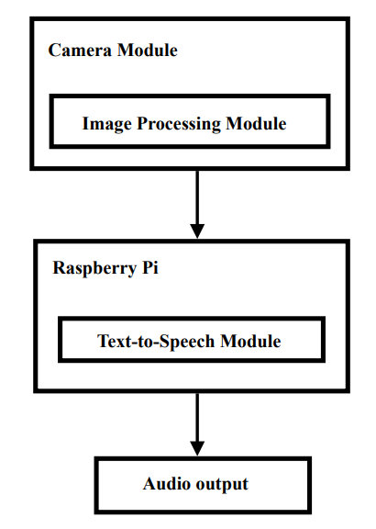

**Fig. 1**: Basic Structure of the Device

The wearable device consists of a camera module and headphones/speaker connected to a Raspberry Pi. The camera module captures an image of the text to be read and sends it to the Raspberry Pi. The Raspberry Pi then uses optical character recognition (OCR) software to convert the image to text, and a text-to-speech (TTS) engine to read the text aloud through the headphones/ speaker.

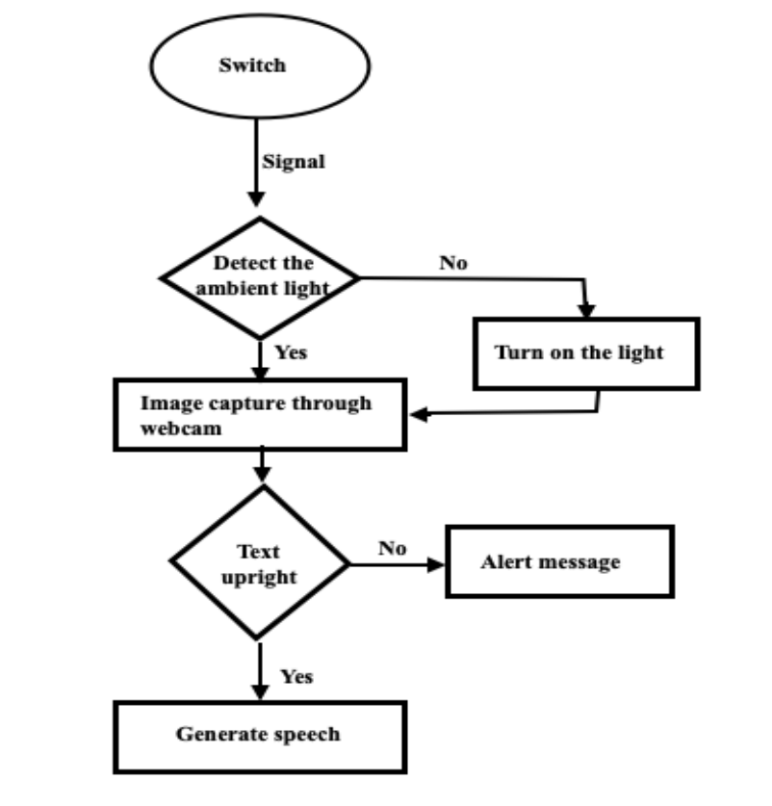

**Fig. 3** Architecture of the Device

The system described above is an innovative combination of hardware and software components designed to facilitate a seamless user experience. It utilizes a Light Dependent Resistor (LDR) sensor to detect the ambient light conditions and automatically turn on the light as needed. Additionally, it incorporates a webcam that captures images, which are then enhanced for optimal clarity and visibility.

Once the image is captured and enhanced, the system employs a novel methodology to extract the word pointed to by the user's finger. This unique approach ensures accurate and reliable word recognition. The extracted word is then passed on to an Optical Character Recognition (OCR) engine, which processes the image and converts the textual content into editable and searchable data.

The OCR engine plays a crucial role in deciphering the text and making it accessible for further processing. It utilizes advanced algorithms and machine learning techniques to recognize characters and convert them into digital format. By harnessing the power of OCR, the system enables users to interact with printed or handwritten text more effectively.

Once the OCR engine completes its analysis, it generates the textual output, which is then passed to a Text-to-Speech (TTS) converter. The TTS converter is responsible for transforming the written text into audible speech. This feature ensures accessibility for individuals with visual impairments or those who prefer auditory information.

To deliver the audio output, the system utilizes an audio output device such as earphones or speakers. This enables users to conveniently listen to the converted text through their preferred audio interface. Whether it's a person using earphones to privately listen to the content or a group of individuals using a speaker for shared listening, the system accommodates different user preferences and scenarios.

The integration of the LDR sensor, webcam, OCR engine, and TTS converter creates a powerful and user-friendly system. Its functionality enhances the accessibility and usability of printed and handwritten text by providing a seamless and efficient workflow from image capture to audio output. This technology has the potential to benefit a wide range of users, including individuals with visual impairments, those with reading difficulties, or anyone who prefers an audio-based information retrieval system.

In conclusion, the system described above utilizes a combination of hardware and software components to detect ambient light conditions, capture and enhance images, extract words pointed to by the user, perform optical character recognition, and convert the text to audible speech. This comprehensive process ensures the accessibility and usability of printed and handwritten text, providing an inclusive and efficient solution for information retrieval.

# CHAPTER 6

**SYSTEM IMPLEMENTATION**

The system being discussed is a cutting-edge fusion of hardware and software elements meticulously designed to deliver an unparalleled user experience. It seamlessly integrates various components to create an efficient workflow that bridges the gap between printed or handwritten text and accessible audio information.

At the core of this system lies a Light Dependent Resistor (LDR) sensor, which plays a vital role in detecting and adapting to the surrounding ambient light conditions. This intelligent sensor ensures optimal illumination by automatically activating the light source when needed. By employing the LDR sensor, the system provides a well-lit environment that enhances image capture and readability.

Complementing the LDR sensor is a high-quality webcam that captures images of the text or document being interacted with. These images are subjected to advanced enhancement techniques, leveraging cutting-edge algorithms to enhance clarity and visibility. By refining the captured images, the system guarantees superior image quality and promotes accurate word recognition, even with challenging or suboptimal input.

To identify the specific word being pointed at by the user, the system employs a unique and innovative methodology. This methodology utilizes sophisticated algorithms and techniques to precisely extract the targeted word from the captured image. The robustness and accuracy of this word extraction process ensure reliable results and enable seamless interaction with the textual content.

Once the targeted word is extracted, it is passed through an Optical Character Recognition (OCR) engine. The OCR engine employs state-of-the-art machine learning algorithms and advanced pattern recognition techniques to analyze the image and convert the textual content into editable and searchable data. This transformative process empowers users to effortlessly interact with printed or handwritten text, making it accessible and convenient for further processing.

Upon completion of the OCR analysis, the system generates a textual output, which is subsequently fed into a Text-to-Speech (TTS) converter. The TTS converter is responsible for converting the written text into audible speech, ensuring accessibility for individuals with visual impairments or those who prefer auditory information. This capability allows users to listen to the converted text through an audio output device such as earphones or speakers, adapting to their individual preferences and needs.

By skillfully integrating the LDR sensor, webcam, OCR engine, and TTS converter, the system offers a comprehensive and user-friendly solution. It optimizes the accessibility and usability of printed and handwritten text, providing a seamless and efficient workflow from image capture to audio output. This powerful technology has the potential to significantly benefit individuals with visual impairments, those with reading difficulties, or anyone who favors an audio-based information retrieval system.

In conclusion, the system described above leverages an intricate blend of hardware and software components to detect ambient light conditions, capture and enhance images, extract user-pointed words, perform optical character recognition, and ultimately convert the text into audible speech. This holistic process ensures the accessibility and usability of printed and handwritten text, presenting an inclusive and efficient solution for information retrieval. wearable assistive device for the blind project aims to develop a device that will help visually impaired individuals navigate their surroundings more easily. The device will use a Raspberry Pi microcontroller as its primary computing platform.

The system implementation of a wearable assistive device for the blind using OCR (optical character recognition) and TTS (text-to-speech) involves several key components. The device itself is worn by the user and includes a camera for capturing text, a processing unit for OCR analysis, and a speaker for TTS output.

When the user points the device’s camera at printed text, OCR software processes the image and converts the text to digital form. This converted text is then sent to the TTS software which converts the text into spoken words that are output through the speaker.

Overall, the system implementation of a wearable assistive device for the blind using OCR and TTS technology provides a powerful tool for individuals with visual impairments to access printed materials.

**6.1 PSEUDO CODE**

Engine= pyttsx3.init()

Engine.setProperty(‘rate’,130)

Image_path=r’/home/sneha/testing.img’

Image = Image.open(image_path)

Text = pytesseract.image_to_string(image)

Engine.say(text)

Engine.runAndWait()

Print(‘done’)

This Python code snippet uses the pytesseract and pyttsx3 libraries to convert text in an image file to speech output. First, the pyttsx3 library is initialized by creating an engine object using `pyttsx3.init()`. Then, the speaking rate of the audio output is set to 130 words per minute using `engine.setProperty(‘rate’,130)`. An image file is loaded into an image object using the `Image.open()` function from the Pillow library, and the path of the image file is specified using the `image_path` variable. The `pytesseract.image_to_string()` function is then called to extract text from the loaded image using OCR technology. The extracted text is passed to `engine.say()` to convert it into speech output using the initialized engine object. `engine.runAndWait()` is called to play the generated audio output, and `print(‘done’)` is used to indicate the completion of the text-to-speech conversion process. Overall, this code demonstrates how the pytesseract and pyttsx3 libraries can be used together to extract text from an image and convert it into speech output. This functionality can be useful for applications such as assistive technologies for individuals with visual impairments.

Image = cv2.imread(‘/home/sneha/testimg.jpg’)

#rgb = cv2.cvtColor(image, cv2.COLOR_BGR2RGB)

Results = pytesseract.image_to_osd(image, output_type=Output.DICT)

# display the orientation information

a=results[“rotate”]

Print(a)

The code snippet reads an image file into an image object using the OpenCV `cv2.imread()` function. The path of the image file is specified using the string `/home/sneha/testimg.jpg`. This function returns a NumPy array that represents the pixel values of the image.Then, the `pytesseract.image_to_osd()` function is used to extract orientation information from the image. The image object is passed to this function, along with the `output_type` parameter set to `Output.DICT`. This causes the function to return a dictionary that contains various information about the orientation of the image, such as the angle by which the image needs to be rotated to be correctly oriented. The extracted orientation Information is then accessed from the dictionary by retrieving the value of the `rotate` key using the `results[“rotate”]` syntax. The value of the `rotate` key represents the angle by which the image needs to be rotated.Finally, the angle value is printed to the console using the `print()` function, which displays the orientation information of the image. This information can be useful in tasks like document processing, where it is necessary to identify the orientation of the document and rotate it to the correct position.

**6.2 METHODS EXPLAINATION**

**6.2.1 OpenCV**

Cv2 is a powerful computer vision library that can be used in a wearable assistive device for the blind. The library provides a range of image and video processing capabilities that can help the device understand the surrounding environment and provide useful information to the user.

Cv2 could be used in a wearable assistive device for the blind:

1. Object detection: The device could use Cv2 to detect and recognize objects in the user's environment, such as doors, chairs, and other obstacles. This information could then be used to provide audio or haptic feedback to the user, helping them navigate their surroundings more effectively.
2. Optical character recognition (OCR): The device could use Cv2 in conjunction with Pytesseract to perform OCR on text in the user's environment. For example, the device could use a camera to capture text on signs or labels and use Cv2 and Pytesseract to convert the text into audio or haptic feedback for the user.
3. Facial recognition: The device could use Cv2 to perform facial recognition, allowing the user to identify familiar faces and avoid potential hazards. For example, the device could use facial recognition to detect a friend or family member and provide audio feedback to the user.
4. Image and video processing: The device could use Cv2 to process image and video data from cameras in real-time. For example, the device could use Cv2 to enhance image quality or adjust camera settings based on lighting conditions, providing a clearer view of the user's environment.

Overall, Cv2 provides a powerful set of tools for image and video processing that can help a wearable assistive device for the blind understand and interpret the surrounding environment. By incorporating Cv2 into such a device, users could benefit from improved navigation and a more intuitive understanding of their surroundings.

**6.2.2 Pytesseract**

Pytesseract is a Python library that allows for optical character recognition (OCR) from images. In the context of a wearable assistive device for the blind, Pytesseract could be used to convert printed text in the user's surroundings into digital text that could be read out loud or displayed on a braille display.

Pytesseract could be used in a wearable assistive device for the blind:

1. Capture image: The device would need to capture an image of the text using a camera or other image-capturing device.
2. Pre-process image: Before passing the image to Pytesseract, it may be necessary to pre-process the image to improve the accuracy of the OCR. This could involve operations such as image binarization, deskewing, or noise reduction.
3. Apply OCR using Pytesseract: The pre-processed image would then be passed to Pytesseract to perform the OCR. Pytesseract would analyze the image to identify the characters and their positions within the image.
4. Extract text: Once the OCR has been performed, the text would be extracted from the image as a string of characters. The extracted text could then be read out loud using a text-to-speech module or displayed on a braille display for the user to read.
5. Repeat for multiple images: The device could continue to capture and analyze images until the user no longer needs the OCR functionality.

**6.2.3 Pyttsx3**

Pyttsx3 is a Python library that provides text-to-speech (TTS) capabilities for applications. In the context of a wearable assistive device for the blind, Pyttsx3 could be used to convert digital text, such as OCR output from Pytesseract, into spoken words that the user could hear through headphones or speakers.

Pyttsx3 used in a wearable assistive device for the blind:

1. Receive text: The device would receive digital text, such as OCR output from Pytesseract, as a string of characters.
2. Apply TTS using Pyttsx3: The device would then pass the text to Pyttsx3 to convert it into spoken words. Pyttsx3 would analyze the text and generate a corresponding audio file.
3. Play audio: Once the audio file has been generated, the device could play the audio through headphones or speakers for the user to hear.
4. Repeat for multiple texts: The device could continue to receive and convert text into spoken words until the user no longer needs the TTS functionality.

Pyttsx3 provides a powerful tool for converting digital text into spoken words, allowing wearable assistive devices for the blind to help users navigate and understand their surroundings more effectively. By incorporating Pyttsx3 into a wearable device, users could benefit from real-time TTS capabilities that could significantly improve their independence and quality of life.

**6.2.4 Image_to_osd**

`Image_to_osd()` is a function in the pytesseract library that is used to extract orientation and script detection (OSD) information from an image. The function takes an image as input and returns a dictionary containing various metadata related to the orientation and script detection of the image. The OSD information can include details such as the angle by which the image is rotated, the script detection confidence, and the orientation confidence.

The `Image_to_osd()` function is useful in applications such as document processing, where it is necessary to correctly orient an image or detect the script used in a document. By extracting OSD information from the image, the function can help automate these tasks and make image processing more efficient.

# CHAPTER 7

**SYSTEM TESTING**

System testing of a wearable assistive device for the blind that uses OCR (Optical Character Recognition) and TTS (Text-to-Speech) is an important process that ensures the device performs as expected before it is released to the market. The testing process involves evaluating the performance, reliability, and usability of the device in different scenarios to ensure it meets the needs of the users and conforms to the requirements and specifications set by the developers.

During system testing, the device is put through a series of test cases that cover various aspects of its functionality, such as OCR accuracy, TTS output quality, response time and connectivity. The tests are designed to simulate real-world scenarios and user interactions to ensure the device can handle different situations that a blind person might encounter.

The testing process also Involves evaluating the usability of the device, including its user interface, ease of use, and accessibility features. This is important to ensure the device is intuitive and easy to use for people with visual impairments.

System testing is crucial for ensuring that the wearable assistive device for the blind using OCR and TTS is reliable, accurate, and user-friendly. By conducting thorough testing, developers can identify and fix any issues or bugs before the device is released to the market, ensuring that it meets the needs and expectations of the users.

**Table 1**:Test cases of Wearable assistive device for blind

|  |  |  |  |
| --- | --- | --- | --- |
| Parameter | Expected Result | Observed Result | Remark |
| No ambience or  Low ambience | Led on | Led on | Pass |
| Effective ambience | No change in light condition | No change in light condition | Pass |
| Rotation degree of image = 0 | Image to text to speech conversion | Image to text to speech conversion | Pass |
| Rotation degree of image captured = 270 or 90 or 180 | Gives alert message to blind via speech | Gives alert message to blind via speech | Pass |

# CHAPTER 8

**EXPERINMENT RESULT AND ANALYSIS**

In the experiment, the wearable assistive device is tested in various scenarios, including indoor and outdoor environments, different lighting conditions, and various font sizes and styles. The device’s OCR accuracy is measured by comparing the text recognized by the device with the actual text in the image, and the TTS output quality is evaluated based on the clarity and intelligibility of the speech.

The experimental result and analysis are essential to the development of a wearable assistive device for the blind using Tesseract OCR and Python TTS. Through careful evaluation and analysis, developers can identify and address issues with the device, ensuring that it meets the needs and expectations of its users.

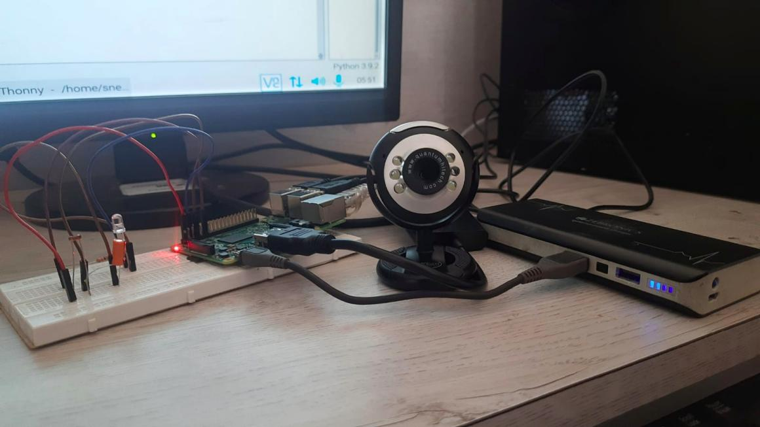

Fig. 8.1 Snapshot of Proper ambience condition

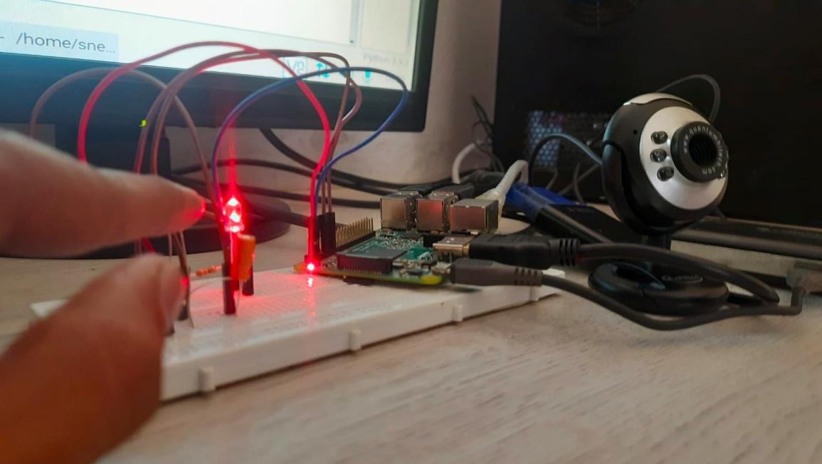

Fig. 8.2 Snapshot of Low ambience condition

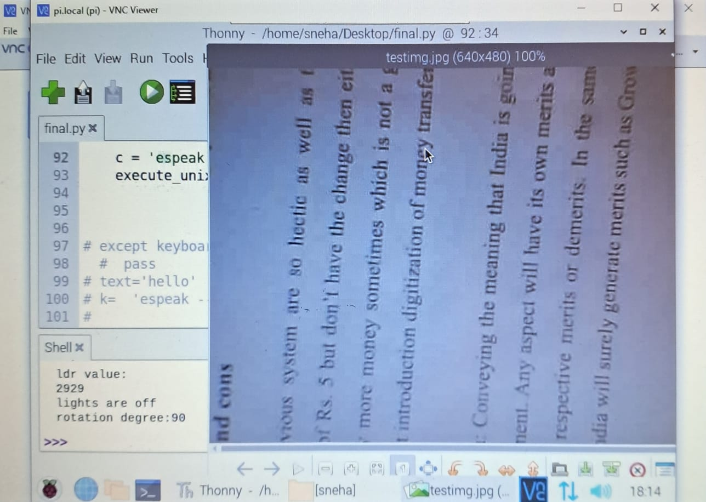

Fig. 8.3 Snapshot of angle of rotation of text in an image

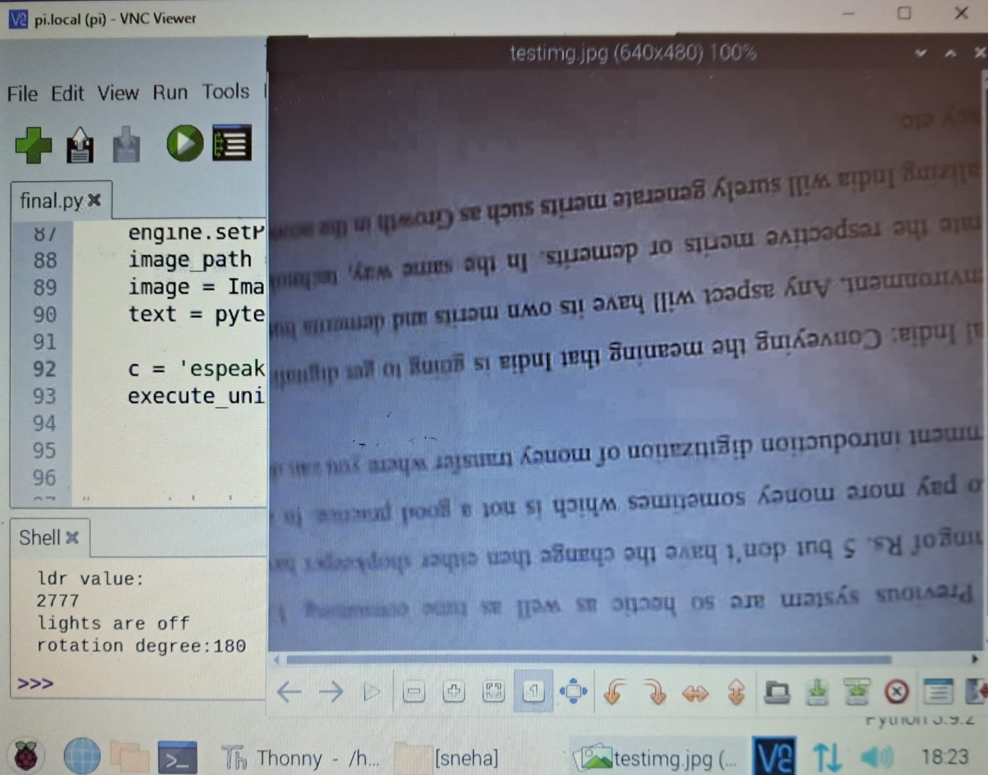

Fig. 8.4 Snapshot of angle of rotation of text in an image

# CHAPTER 9

**CONCLUSION**

In conclusion, the journey of developing assistive technologies for visually impaired individuals has been marked by significant advancements and innovations. The initial focus on generating Braille equivalents provided a valuable means of accessing reading resources, but practical limitations such as bulkiness, cost, and time-consuming processes hindered their widespread adoption. As a result, alternative technologies emerged, aiming to provide various forms of feedback for printed text, and the introduction of the Digital Accessible Information System (Daisy) standard revolutionized the reading experience by combining text and audio components.

Early attempts to convert visual signals into non-verbal acoustic or tactile outputs, such as the Optophone and Optacon devices, showed promise but were limited in terms of hand movement requirements and the ability to use both hands freely while reading. However, the advent of optical character recognition (OCR) technology brought about a new wave of innovation. OCR enabled the extraction of text from images, leading to the development of mobile apps and devices that utilized OCR and speech synthesis to capture and read text.

Mobile apps like KNFB Reader and Blindsights Text Detective provided a more accessible way for visually impaired individuals to access reading materials. These apps, however, required proper alignment, lighting, and focus to achieve optimal results, and often read blocks of text as a whole without providing contextual information. Specialized devices such as Eye-Pal, OrCam, iCare, and Finger Reader tackled these challenges by utilizing cameras to capture images of text and providing auditory or tactile feedback. While these devices offered real-time effects and improved accessibility, they were often bulky, required external components or complex hardware setups, and were not always cost-effective.

The existing literature reveals a pressing need for a computationally inexpensive algorithm that can effectively address the challenges faced by visually impaired individuals in accessing reading resources. Current systems often rely on software technologies with complex hardware setups, leading to cost and portability issues. This paper sought to address these challenges by presenting a simple algorithm that offers satisfactory results using cost-effective methodologies.

Moving forward, there is still a demand for more accessible and affordable solutions that can effectively meet the needs of visually impaired individuals in accessing reading resources independently. Technological advancements and the continuous improvement of OCR, computing power, and algorithms hold great promise for the future. Efforts should focus on developing user-friendly, portable, and cost-effective solutions that can seamlessly integrate into the daily lives of visually impaired individuals.

Additionally, collaboration among researchers, developers, and organizations dedicated to improving the lives of visually impaired individuals is crucial. By combining expertise and resources, innovative solutions can be created, ensuring that visually impaired individuals have equal access to reading resources and can participate fully in various aspects of life.

In conclusion, while significant progress has been made in the field of assistive technologies, the work is far from complete. The ongoing pursuit of accessible and affordable solutions will continue to make a profound impact on the lives of visually impaired individuals, empowering them to access reading resources independently and promoting inclusivity and equality in society.

# REFERENCES:

|  |  |
| --- | --- |
| [1] | Visual impairment and blindness 2010," 2013. [Online]. Available: http:// www.who.int/ blindness/data_maps |
| [2] | Trupti Shah and Sangeeta Parshionikar :Efficient Portable Camera Based Text to Speech Converter for Blind Person, |
| [3] | Arunima B Krishna, Meghana Hari and Dr. Sudheer A.P : Word Based Text Extraction Algorithm Implementation in Wearable Assistive Device for the Blind, |
| [4] | Shalini Sonth and Jagadish S. Kallimani : OCR based facilitator for the visually challenged |
| [5] | Prabhakar Manage,Veeresh Ambe, Prayag Gokhale, Vaishnavi Patil, Rajamani M.Kulkarni, Preetam R. Kalburgimath. : An Intelligent Text Reader based on Python. |
| [6] | M. A. Hersh and M. A. Johnson, Eds. Berlin : D. Keating, Assistive technology for visually impaired and blind people : Springer London, 2008. |